Carlo Cruz BSIT 3-E TESTQUA
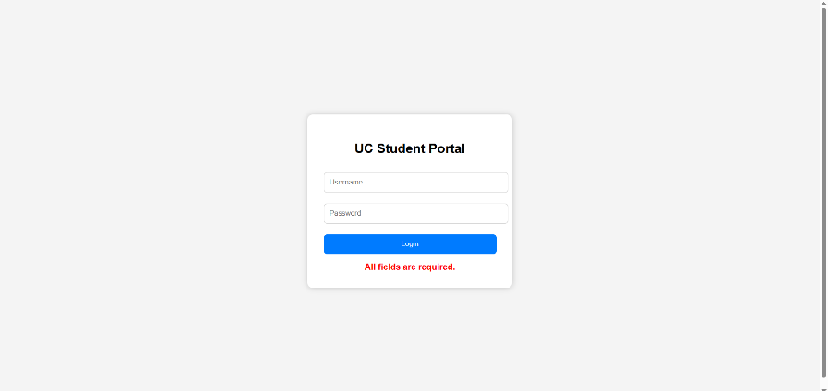

Expected Result: The same lang ani na all required field are required
Actual: same as I expected all field are required
Status: PASS
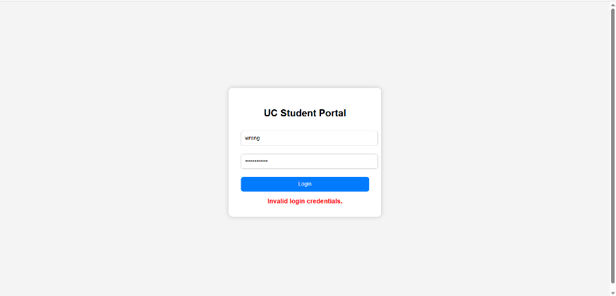

Expected Result: The same lang invalid login credential since I type the wrong ones.
Actual: same as I it will be invalid credentials
Status: PASS

